Distortion Wave

How to launch it.

By Ivan Martsilenko.

To launch in Microsoft Visual Studio 2019 you need to open github.com via <https://github.com/IvanMartsilenko/wave> and press button “Open with visual studio”

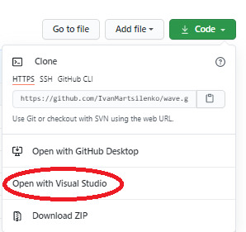.

After that, in Microsoft Visual Studio 2019 you need to link solution to **gdiplus.lib** (this library was used to draw image in window).

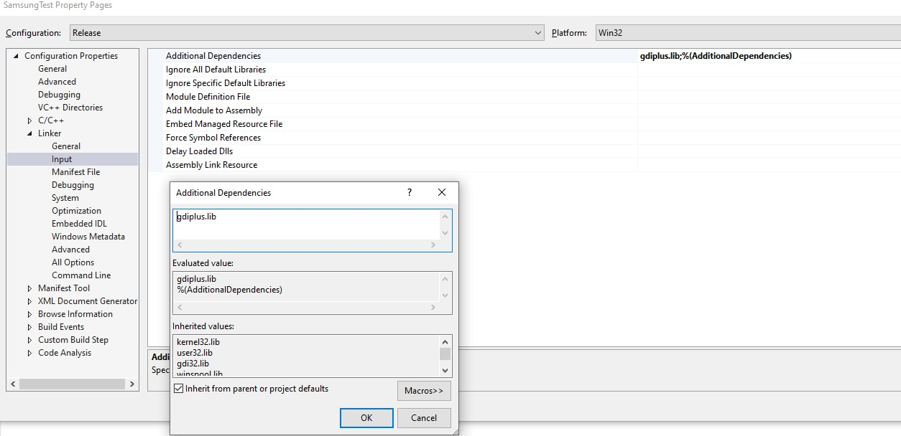

It must be **Windows Desktop Application** solution.

So, now you can press F5 and you will see something like this. 

The program deal with Basic requirements from 0 to 4 and 6. By the way, it don’t have usual interface, so to tunning parameters of waves you should open Samsung.cpp and in rows 21-25 change parameters for anyone you want.

Program can work only with BPM files!

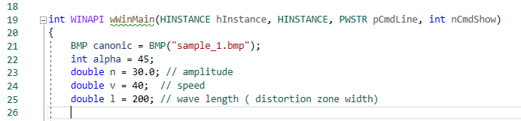

You also can use some random values for wave generation.

To do it in the same file in row 27 you should change parameters.

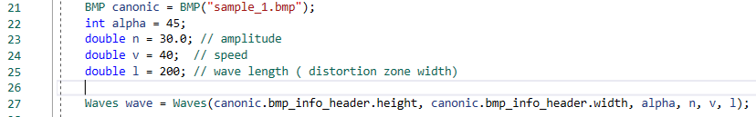

Waves constructor have some overloads, so u can try some combination of random parametres.

The list of constructor overloads ( a means alpha):

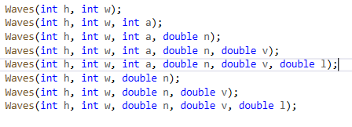

Also, you can change a background image ( only BMP files). You can try “this_is_fine.bmp” or any other bmp files.



Wave will pass only once, after that you need to close window and press “F5”one more time.

Thanks for reading, for details you can open file “DocumentationTestTask.docx”